JAMES’ GUIDANCE ON COMPLETING PART B OF THE NATIONWIDE FORM – 2027 EDITION
- Please enter your FULL name (i.e. including middle names), FULL address and the post code on Part B of the form.
These details will be cross-referenced by Nationwide to verify that you are an eligible customer / member. Nationwide will likely reject forms that don’t include your full name and full address i.e. these need to match exactly what Nationwide holds on record.
- Your “share account number” is your current / savings account details (i.e. the 8 digit account number assigned to you by Nationwide). Alternatively, you can provide your 10-11 digit mortgage account number if relevant.
These details are not mandatory to be an eligible and valid nomination, but Nationwide has requested these are added, if possible, to speed up the verification process. See the notes at the end of this document for more information.
- Please add your signature to Part B so that it matches Nationwide's records.
If Part B is unsigned, or the signature does not match, your nomination is unlikely to be accepted by Nationwide. Your signature on the form does not need to be a “wet ink” signature - e.g. it can be a copy/image of your signature - but it does need to closely resemble the signature Nationwide has on file for you.
- Please include the date of when you sign the form.
Undated forms are unlikely to be accepted by Nationwide. Forms need to be dated within the current financial year which runs from 1st April 2026 to 31st March 2027.
- Please return PART B ONLY of the completed form to me by 1ST SEPTEMBER 2026.
Nationwide has requested that nominations are collected by me and delivered in a batch, asap.
- YOU ONLY NEED TO RETURN PART B, scanned or photographed, to nominate@james4nationwide.co.uk. Alternatively, you can post PART B to my address given in Part A.

- IF YOU DON’T HAVE A PRINTER / CAN’T ADD YOUR SIGNATURE, you could
  - Sign a white piece of paper (that matches what the society has on file), take a photo with a smart phone and email it to me. I will then add it to your form and email the completed form to you to verify, OR
  - Ask a friend or family member to print the form and email it to me, OR
  - Email me and I will post you a form to complete & return by post.

- Please check you are eligible to nominate by reviewing the Nationwide notes on page 4.

- Should you have any questions, please do not hesitate to contact me.
Email is best james@james4nationwide.co.uk
Thank you for your support!

TEMPLATE FORM OF NOMINATION
This nomination (comprising Parts A and B) must be received by the Society at its head office, addressed to the Secretary accompanied by a deposit of £500 by the end of the financial year preceding the election.
PART A - FOR COMPLETION BY THE CANDIDATE:
CANDIDATE FOR NOMINATION
Full name: | James Alexander Ralph SHERWIN-SMITH
Full address (including postcode): | Westbrook, Lake View Road, Furnace Wood  Felbridge, East Grinstead, West Sussex, RH19 2QE
Email address: | james@james4nationwide.co.uk
Contact number: | 07359 225554
I, the undersigned, whose details are as set out above, confirm that:
- I wish to stand for election to the board of directors of Nationwide Building Society (the “Society”);
- I agree to be nominated for election in accordance with the Rules of the Society;
- I will be at least 18 years of age at the date of election; and
- I am not prohibited by law from being a director and will notify the Society promptly in the event that I become prohibited from serving as a director.
SIGNED: | 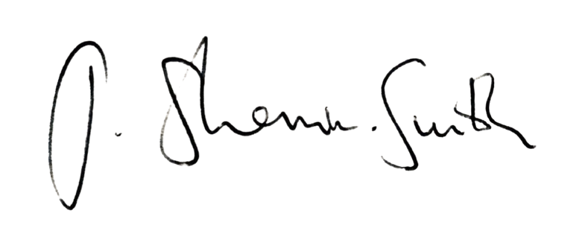
DATE: | 2 APRIL 2026

TEMPLATE FORM OF NOMINATION

PART B - FOR COMPLETION BY EACH NOMINATING MEMBER:
Each nominating member should read the notes below carefully before completing this section.
NOMINATING MEMBER
Full name*:
Full address (including postcode)*:
Share account number(s):
(optional)
Mortgage loan account number(s):
(optional)
I, the undersigned, whose details are as set out above, confirm that:
- I wish to nominate the candidate detailed in Part A above (James SHERWIN-SMITH) to stand for election to the board of directors of Nationwide Building Society; and
- I satisfy and, in the case of a future date, will to the best of my knowledge satisfy the conditions set out in Note 2 below.
SIGNED*:
DATE*:

* Mandatory information for a valid nomination.

Nationwide’s accompanying notes
- The nomination of a candidate for election as a director may be made by 250 “qualified two year” members.
- A member is a “qualified two year” member if the member:
  - is at least 18 years of age at the date on which Nationwide Building Society (the “Society”) receives the nomination; and
  - held a share investment with the Society with a value of at least £200 throughout the period of two years ending on the date on which the Society receives the nomination; or
  - owed the Society at least £200 on a mortgage loan throughout the period of two years ending on the date on which the Society receives the nomination.
- Each nominating member should provide in Part B all share or mortgage loan account numbers necessary to show that he/she has been a “qualified two year” member throughout the continuous two year period specified. This may require providing more than one account number where different accounts have been held throughout the period. Failure to provide the relevant information may result in the form being rejected as invalid.
- Each nominating member must provide their full name and address (including postcode) for the purposes of identification. Failure to provide full details may result in the form being rejected as invalid.
- In the case of joint members, only the first named joint member may join the nomination.
- Nominating members are not required to sign the same physical document.

